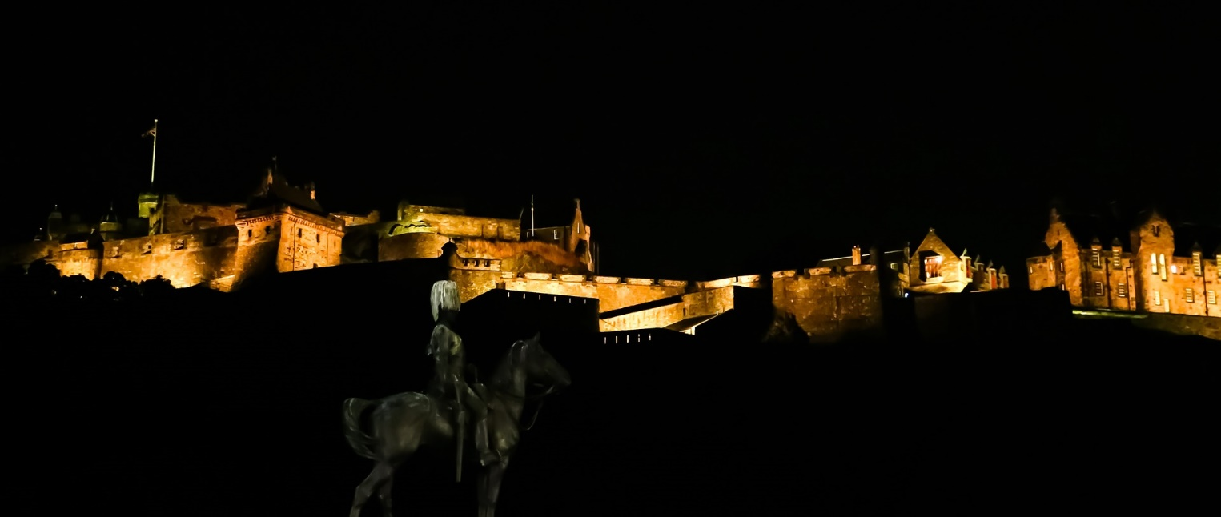

**At St-Columba’s-by-the-Castle, Edinburgh**

**28-29 October 2017**

**The Sleepover by the Castle**

Dress (optional): magical, medieval, fantastical,knightly

**SCOTTISH EPISCOPAL CHURCH**

## **THE SLEEPOVER BY THE CASTLE 28.10.17**

**WHERE? St Columba’s by the Castle, 14 Johnston Terrace, Edinburgh EH1 2PW**

**WHEN? Saturday 28 October - Sunday 29 October**

**Drop off on Saturday at 2.30pm; pick up on Sunday at Noon (the young people have been invited to lead part of the service: 10am Eucharist. Families are welcome to join us for the service)**

**CONTACT? Claire Benton-Evans youthandchildren@dioceseofedinburgh.org Work mobile: 0747 372 8148**

**DRESS: appropriate for a castle: medieval, magical, fantastical, beastly or knightly (optional)**

**COST: £6 (Cheques made payable to Diocese of Edinburgh)**

**Further information overleaf.**

**SCOTTISH EPISCOPAL CHURCH**

## **THE SLEEPOVER BY THE CASTLE 28.10.17**

This event has been organised by the Youth and Children Officer for Edinburgh Diocese, on behalf of the Provincial Youth Committee. It will be led by a team of Glenalmond leaders, all of whom are PVG checked. This sleepover event is a social get-together for Glenalmond delegates and an opportunity to invite friends and would-be delegates (S1-S6) to join in the fun. We are very grateful to the Rector and Vestry of St Columba’s for agreeing to host this event.

St Columba’s facilities include a large hall, a modern kitchen and several bathrooms. These are designated Ladies and Gents. The young people will sleep ‘dormitory style’ in the hall with girls on one side, boys on the other and leaders in the middle. There will be Glen-style games and activities on Saturday afternoon-evening, and the young people have been invited to lead part of the worship on Sunday morning. This is an exciting chance to use their experiences of devising their own creative worship at Glen! This event includes a Saturday evening meal and Sunday breakfast.

**Address:** St Columba’s by the Castle, 14 Johnston Terrace, Edinburgh EH1 2PW

**How to get there by car:**

St. Columba’s by the Castle is situated a short distance down Johnston Terrace, near to Edinburgh Castle and the Festival Hub, and next-door to the Castle Rock Hostel. The church can be recognised by the large blue door. There are double yellow lines outside the door, and parking on Johnston Terrace is limited, but leaders will be outside the church to meet delegates on arrival and enable a quick drop-off. The nearest NCP car park is Castle Terrace, Edinburgh EH1 2EW – walk up the hill onto Johnston Terrace from there.

Accessibility: Vehicles displaying a Blue Badge may park on the double yellow lines outside the door, and there is step-free access to the church, the hall and the garden.

**Train/Bus:** From Waverley station, head up the Royal Mile – St Columba’s is to the left of Edinburgh Castle. The church is near buses that stop on George IV Bridge and at the Usher Hall.

**Please bring:** Pisky Bingo card, sleeping bag, airbed/mat, pillow, towel, toiletries, any necessary medication, pyjamas, change of clothes, a torch, mug for hot chocolate, musical instrument(s) if you’d like to play on Sunday. A tin of home baking if possible!

**NB Help may be available for transport costs – please contact your diocesan youth representative for details.**

**Parental permission and payment by Monday 16 October please.**

To book a place, please send a cheque and return your signed consent form to: Claire Benton-Evans, 21a Grosvenor Crescent, Edinburgh EH12 5EL

Or contact me via email for an electronic version of the form: [youthandchildren@dioceseofedinburgh.org](mailto:youthandchildren@dioceseofedinburgh.org)

**SCOTTISH EPISCOPAL CHURCH**

## **THE SLEEPOVER BY THE CASTLE 28.10.17**

## **CONSENT FORM**

In order to ensure your child’s safety, we would be grateful if you could complete and return this form.

Please let us know if there are any significant changes. A copy will be retained confidentially by the group leader, Claire Benton-Evans youthandchildren@dioceseofedinburgh.org

**Name of child or young person Church**

|  |  |  |
| --- | --- | --- |
|  |  |  |

**Diocese Date of Birth**

|  |  |  |
| --- | --- | --- |
|  |  |  |

**Address of child or young person**

|  |
| --- |
|  |

**Has this young person taken part in a Glenalmond Youth Week? YES** 🞏 **NO** 🞏

**Name of person with parental responsibility**

|  |
| --- |
|  |

**Contact email address**

|  |
| --- |
|  |

**Telephone No.**

|  |  |  |  |
| --- | --- | --- | --- |
| **Day** |  | **Evening** |  |

**Name of additional contact with parental responsibility** *(in case of emergency):*

|  |
| --- |
|  |

**Telephone No.**

|  |  |  |  |
| --- | --- | --- | --- |
| **Day** |  | **Evening** |  |

**Details of any regular medication, medical condition, mental health issue (eg allergies, asthma, anxiety, epilepsy, diabetes, dietary needs) or disability which leaders should be aware of:**

|  |
| --- |
|  |

**PARENTAL CONSENT**

* I give permission for my child, as named above, to take part in this activity
* I understand that while involved in the activities of this group, he/she will be under the control and care of the group leader and/or other adults approved by the church leadership and that, while the staff in charge of the group will take reasonable care of the children, they cannot necessarily be held responsible for any loss, damage or injury suffered by my child during, or as a result of, the activity

In an emergency and/or if I cannot be contacted, I am willing for my child to receive necessary hospital or dental treatment, including an anaesthetic. **YES** 🞏 **NO** 🞏

**SCOTTISH EPISCOPAL CHURCH**

**USE OF PHOTOGRAPHIC IMAGES CONSENT FORM**

**FOR CHILDREN AND YOUNG PEOPLE (UNDER 18)**

To comply with the Data Protection Act 1998 we need your permission before we use any images of your child/children. Please answer the questions below and then sign and date the form.

|  |  |
| --- | --- |
| Name of child |  |

**TO BE COMPLETED BY PERSON/ORGANISATION REQUESTING PERMISSION**

|  |  |
| --- | --- |
| Location of photograph | St Columba’s by the Castle – The Sleepover by the Castle |
| Purpose for taking photograph | Promoting Glenalmond Youth Weeks and youth activities in the Scottish Episcopal Church |
| Media to be used | Photographs |

**TO BE COMPLETED BY PARENT/GUARDIAN OR CARER:**

|  |  |  |
| --- | --- | --- |
| May we use your child’s image in our promotional publications? | **Yes** | **No** |
| May we use your child’s image on the Scottish Episcopal Church website and its diocesan websites? | **Yes** | **No** |

Please note that websites can be viewed throughout the world in countries that do not have strict laws relating to the use of personal data or images.

I have read and understand the conditions of use* printed below.

|  |  |  |  |
| --- | --- | --- | --- |
| **Signature** |  | **Date** |  |

|  |  |
| --- | --- |
| **Print Name (in block capitals)** |  |

**Relationship to the child**: Parent/Guardian/Carer (delete as appropriate)

**TO BE COMPLETED BY YOUNG PERSON:**

|  |  |  |
| --- | --- | --- |
| Would you like to contribute musically to the Sunday service? (This could be a solo/small group performance, before/during/after the service, your choice of piece. There will be time for rehearsal on Saturday.) | **Yes** | **No** |
| If so, please give details of instrument(s) and/or voice: | | |

**\*Conditions of use** This consent is valid for two years from the date of signing and will automatically expire after this time and the image will be destroyed. We will not re-use any images after this time. We will not include details of full names (i.e. first name and surname) of any child in an image on our website, or in printed publications without good reason. If we use images in a group they will only be identified with a general label e.g. “children at the Church Fair”. We will not include personal e-mail or postal addresses, or telephone or fax numbers on video, our website or printed publications. We will only use images of young people who are suitably dressed to reduce the risk of such images being used inappropriately.