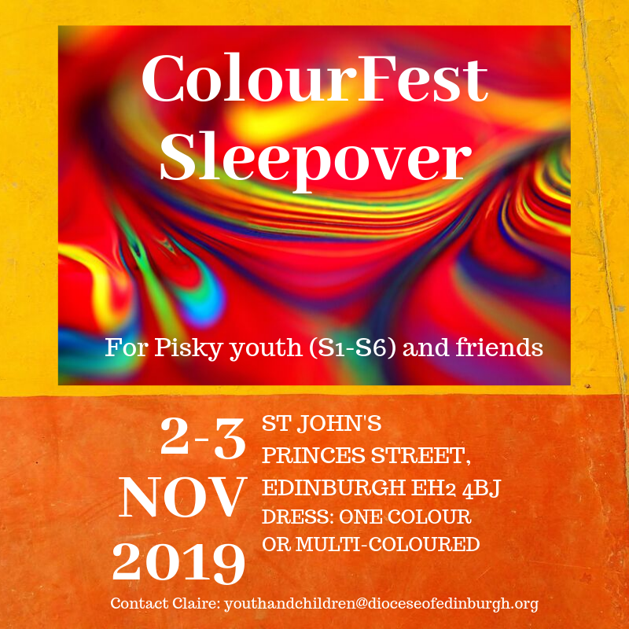

**SCOTTISH EPISCOPAL CHURCH**

## **COLOURFEST SLEEPOVER**

**WHERE? St John’s Princes Street, Edinburgh EH2 4BJ**

**WHEN? 2-3 November 2019**

**Drop off 3pm on Saturday 2nd; pick up Sunday 3rd at noon. The young people will be helping to lead Sunday worship, which begins at 10.30am. Families are welcome to join us for the service**

**CONTACT? Claire Benton-Evans** [**youthandchildren@dioceseofedinburgh.org**](mailto:youthandchildren@dioceseofedinburgh.org)

**Work mobile: 0747 372 8148 Please let Claire know you’re coming.**

**DRESS (optional): One colour or rainbow/multi-coloured**

**COST: £6 (cheques payable to Diocese of Edinburgh or pay on the day)**

**Further information overleaf. Please return the consent form BEFORE the event.**

This event has been organised by Claire Benton-Evans, Youth & Children Officer of Edinburgh Diocese, on behalf of the Provincial Youth Committee. It will be led by a team of Glenalmond leaders, all of whom are PVG checked. This sleepover event is a social get-together for Glen delegates (S1-S6, plus this year’s Glen graduates) and an opportunity to invite friends and would-be delegates to join in the fun. We are very grateful to the Rector and Vestry of St John’s Princes St for agreeing to host this event.

St John’s facilities include a large modern annexe with a kitchen and several bathrooms. These will be designated Ladies and Gents. The young people will sleep ‘dormitory style’ in the annexe with girls on one side, boys on the other. Leaders will sleep in the middle. There will be Glen-style games and activities on Saturday afternoon-evening. The young people have been invited to lead part of the worship on Sunday morning. This event includes a Saturday evening meal and Sunday breakfast. **Please note that after the evening film there will be ‘lights out’ and quiet in the main hall, to allow delegates to get enough sleep.**

**SPECIAL FEATURE!**

There will be a unique opportunity to design a new mural for outside St John’s Princes St. The mural artist has agreed to work with our young people on a mural that will express what they feel strongly about and want to say to the world. It could be a challenge, a plea, a protest; it will feature the PYC logo and everyone who contributes to the mural will officially become one of the 'Artists for Justice and Peace'! Greg the artist will be running a mural workshop at the sleepover and everyone can contribute to the design if they wish. There will be an opportunity for up to 10 volunteers to help Greg with the actual painting over the two following Saturdays. For more information about the murals, see the Facebook page: [Murals at St John’s, Edinburgh](https://www.facebook.com/Murals-at-St-Johns-Edinburgh-192612720787609/)

**Address:** St John’s Princes St, Edinburgh EH2 4BJ

**How to get there by car:** The nearest NCP car park is [Castle Terrace](https://www.ncp.co.uk/find-a-car-park/car-parks/edinburgh-castle-terrace/); there is on-street parking in Melville St nearby (max 4 hours, free after 6.30pm and on Sundays)

**Train/Bus:** St John's is at the west end of Princes Street, about 10 minutes’ walk from either Edinburgh Waverley or Haymarket station. Many bus routes stop near to the church in Princes Street or Lothian Road. For information on public transport see [Lothian Buses](http://www.lothianbuses.co.uk/) or [Traveline Scotland](http://www.travelinescotland.com/).

NB Help may be available for transport costs – please contact your diocesan youth representative for details.

**Please bring:** Pisky Bingo card, sleeping bag, airbed/mat, pillow, towel, toiletries, any necessary medication, pyjamas, change of clothes, a torch, musical instrument(s) if you’d like to play on Sunday. A tin of home baking if possible! Dressing up is optional: the theme is Colours so costumes could include an entire outfit of one colour, rainbow colours or multi-colours. Please can everyone who comes bring along an image (in hard copy) that represents something they feel strongly about. These will form the basis of the mural design process.

**To book a place, please let me know by email: youthandchildren@dioceseofedinburgh.org**

**Email a scan/photograph of your signed consent form to this address, or post to: 21a Grosvenor Crescent, Edinburgh EH12 5EL. You can send a cheque payable to Diocese of Edinburgh or pay on** **the day. Consent forms in by 29.10.19 please.**

**SCOTTISH EPISCOPAL CHURCH**

## **COLOURFEST SLEEPOVER 2-3 NOV 2019**

## **CONSENT FORM**

In order to ensure your child’s safety, we would be grateful if you could complete and return this form.

Please let us know if there are any significant changes. A copy will be retained confidentially by the group leader, Claire Benton-Evans.

**Name of child or young person Church**

|  |  |  |
| --- | --- | --- |
|  |  |  |

**Diocese Date of Birth**

|  |  |  |
| --- | --- | --- |
|  |  |  |

**Address of child or young person**

|  |
| --- |
|  |

**Has this young person taken part in a Glenalmond Youth Week? YES** 🞏 **NO** 🞏

**Name of person with parental responsibility**

|  |
| --- |
|  |

**Contact email address**

|  |
| --- |
|  |

**Telephone No.**

|  |  |  |  |
| --- | --- | --- | --- |
| **Day** |  | **Evening** |  |

**Name of additional contact with parental responsibility** *(in case of emergency):*

|  |
| --- |
|  |

**Telephone No.**

|  |  |  |  |
| --- | --- | --- | --- |
| **Day** |  | **Evening** |  |

**Details of any regular medication, medical condition, mental health issue (eg dietary needs, allergies, asthma, anxiety, epilepsy, diabetes) or disability which leaders should be aware of:**

|  |
| --- |
|  |

**PARENTAL CONSENT**

* I give permission for my child, as named above, to take part in this activity
* I understand that while involved in the activities of this group, he/she will be under the control and care of the group leader and/or other adults approved by the church leadership and that, while the staff in charge of the group will take reasonable care of the children, they cannot necessarily be held responsible for any loss, damage or injury suffered by my child during, or as a result of, the activity

In an emergency and/or if I cannot be contacted, I am willing for my child to receive necessary hospital or dental treatment, including an anaesthetic. **YES** 🞏 **NO** 🞏

**SCOTTISH EPISCOPAL CHURCH**

**USE OF PHOTOGRAPHIC IMAGES CONSENT FORM**

**FOR CHILDREN AND YOUNG PEOPLE (UNDER 18)**

To comply with General Data Protection Regulation (Regulation (EU) 2016/679) we need your permission before we use any images of your child/children. Please answer the questions below, then sign and date the form.

|  |  |
| --- | --- |
| Name of child |  |

**TO BE COMPLETED BY PERSON/ORGANISATION REQUESTING PERMISSION**

|  |  |
| --- | --- |
| Location of photograph/video | St John’s Princes St |
| Purpose for taking photograph/video | Promoting youth events in the Scottish Episcopal Church |
| Media to be used | Photographs/video |

**TO BE COMPLETED BY PARENT/GUARDIAN OR CARER/OR BY THE YOUNG PERSON (12+)**

|  |  |  |
| --- | --- | --- |
| May we use your child’s image in our promotional publications? | **Yes** | **No** |
| May we use your child’s image on the Scottish Episcopal Church website/social media and its diocesan websites/social media? | **Yes** | **No** |

Please note that websites/social media can be viewed throughout the world in countries that do not have strict laws relating to the use of personal data or images.

I have read and understand the conditions of use* printed below.

|  |  |  |  |
| --- | --- | --- | --- |
| **Signature** |  | **Date** |  |

|  |  |
| --- | --- |
| **Print Name (in block capitals)** |  |

**Relationship to the child**: Parent/Guardian/Carer (delete as appropriate)

**\*Conditions of use** We will not include details of full names (i.e. first name and surname) of any child in an image on our website/social media or in printed publications without good reason. If we use images in a group they will only be identified with a general label e.g. “children at the Church Fair”. We will not include personal e-mail or postal addresses, or telephone or fax numbers on video, our website/social media or printed publications. We will only use images of young people who are suitably dressed to reduce the risk of such images being used inappropriately.

**TO BE COMPLETED BY YOUNG PERSON:**

|  |  |  |
| --- | --- | --- |
| Would you like to contribute musically to the Sunday service? (This could be a solo/small group performance, before/during/after the service, your choice of piece. There will be time for rehearsal on Saturday.) | **Yes** | **No** |
| If so, please give details of instrument(s) and/or voice: | | |