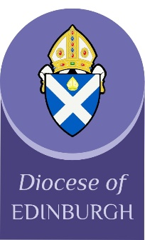
Youth and Children Grant Applications 2021

This year there is no closing date for applications. You are welcome to apply at any time: I hope this helps during these uncertain times when restrictions and plans keep changing.
Please answer the following questions:
What do you plan to use the grant for? (Please note that repeat applications for the same activity/event/resource will not usually be considered)

How will this help your work with children and young people?

How much do you expect this to cost? (A detailed breakdown would be helpful. Grants are normally about £50-£100, but may be more this year, as there have been fewer claims during lockdown.)

If you receive a grant, we would like to pay you online. Please supply bank details for your church.

Thank you for your application. Please return via email to: youthandchildren@dioceseofedinburgh.org
Claire Benton-Evans
Diocesan Youth and Children Officer

