Diocese of Edinburgh Lent Course 2024
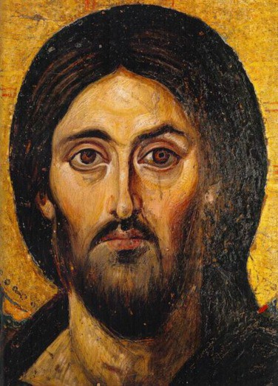
The Emotions of Jesus

Introduction
Welcome to this year’s Lent Course in the Diocese of Edinburgh. We were encouraged by the response from many different churches last year and have tried to keep the format of this year’s study similar. This means that for each week, we have provided many more resources and prompts for discussion than we expect you to need. This is so that you have a choice, concentrating on the resources that best fit where you are as a group.

As we thought about this year, we wanted to offer something to encourage encounters with the human Jesus, but in a way that enabled us to examine our own hearts and how we live and work in the Kingdom of God each day.
Emotions have a profound impact on our lives, especially in the living out of our relationships with others. Our starting point in this booklet is that emotions are not ‘bad’ or ‘good’, but that each emotion can be expressed in life giving or life harming ways. How we express our emotions is often socially and culturally determined, but at their heart, emotions can inform us of who we are, what our relationship with others is like and how we should behave in our social interactions. Emotions give meaning to events, they say something about who we truly are, they spring from our own circumstances (our pain, tiredness, rest and fullness), and are also responses to external influences (both people and events).

We believe that Jesus was fully human. As such, he would have experienced the full raft of emotions as he responded to the community around him.
However, in our gospel narratives, there are few overt expressions of his emotional response (normally in grief and sadness). We are all emotional beings, and often respond emotionally without thought or judgement. This year, we’d like to invite you to explore what it means to have a healthy and robust emotional life, acknowledging and ‘owning’ our emotions and our emotional responses.

We have chosen five emotions that we hope will resonate with your own experience of being human. Emotions have both positive and negative expressions, and we hope that through these studies, you will come to a fuller understanding of who you are, the emotions that God has uniquely given you,

and discern how you feel God is calling you to express and use these amazing gifts.

We have once again offered a ‘Holy Week’ reflection. We are aware that many groups do not meet in Holy Week, but we were also aware of the huge range of emotions present in Jesus and in those around him, during that week. The pictures we have found could be used for your own private prayer during the week, or for a discussion if the group wishes to meet.

How to use this course:
- Choose what suits your group from the different resources for each week
- Sometimes the prayer suggestions could have been offered for any of the weeks – please free to adapt one that your group has found particularly useful to another week.
- Sometimes the passages from the Bible would be too great to include in this booklet, so there may be weeks when you wish to use your own Bible. If you don’t have access to one, the NRSV is available on oremus.org
- This booklet is available in both pdf and Word formats

Liz O’Ryan, David Paton-Williams, Sophia Marriage

Invitation from Bishop John
Open any hymn book or study a communion liturgy and you will soon find yourself bumping up against emotions. Joy, sadness, guilt, gratitude, the whole range is there. Yet, ironically, we sometimes find feelings problematic.
Perhaps it is our northern European mindset, or maybe we fear that emotion undermines our ability to
reason. Yet we know enough about the way our minds work nowadays to recognize that unacknowledged feelings can sometimes work themselves out in destructive ways. And how often the appearance of cool objectivity is simply a mask for prejudice and lack of empathy!
It is good to be reminded that God’s Incarnation embraces our full humanity, including our emotions. Reminded not only that it is good to be people who feel, but that often God speaks to us through our feelings, when our rational minds refuse to listen. I am grateful to Liz O’Ryan, Sophia Marriage and David Paton-Williams for this inspiring study course. Week by week we are invited to pay attention to the Jesus we meet in the gospels, to value his emotions and so to value our own.
This study course will make you think… and it will make you feel.

+John

Gratitude
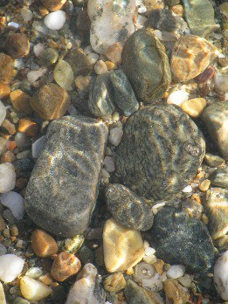
As we consider gratitude this week, it might be useful to define the word right at the outset, and consider its relationship with the more common word ‘thankfulness.’ Thankfulness is an emotion felt in response to something or someone doing something for us, for the kindnesses and gifts received. It is an expression of pleasure, satisfaction and delight, which is often short lived. We may, of course, feel thankful towards God for all the blessings God has bestowed upon us, all of which is good and vital for our relationship with the divine. However, gratitude describes more of an deeper attitude towards life, God and our daily
life. Being grateful is a choice; it is a change of perspective. It focuses on the good instead of what is missing. It is an appreciation of life even when nothing exciting is happening. It is not dependent on anyone else, or even necessarily one’s circumstances. Gratitude is independent, long term and deep. Gratitude, perhaps even more than thankfulness, needs to be practised and is a way of worshipping God. Gratitude leads to a contentment and recognition of God’s presence in each moment.

Anne B had not had an easy life. She had been sexually abused by her uncle whilst still very young, and encountered the same when placed in two different Children’s homes in her youth. After years of severe decreasing mental health she was sectioned in hospital, where violence seemed to be her only possible communication. In middle age she was diagnosed with Motor Neurone Disease which slowly wasted her limbs and gave her daily pain. She met her soul mate in her fifties and planned to marry, but he died of a heart attack before that could happen, only a year after their meeting. Anne had became a Christian very late in life but the reality of God’s love for her changed her world. Despite what had happened to her, Anne became one of the most positive people you could meet. If ever asked how she was, she would reply:

“I’m grateful. Grateful. I give thanks every morning to God for my life. I give thanks for Rainbow, my cat, and the company he gives. I give thanks that I can often make people laugh. I give thanks for God for loving me.” Anne died of Covid in late 2020 aged just 62.
Corrie ten Boom and her sister Betsie were being held in a German concentration camp, a horrific, flea-ridden, death-dealing place. Both girls were afraid, but started a clandestine prayer and Bible meeting in their barracks for amongst the girls in the camp. One evening, Betsie quoted a passage from 1 Thessalonians: “. . .give thanks in all circumstances.” Corrie quickly replied that she could not give thanks for the fleas. Betsy reminded her that she could give thanks that the two of them were together, as most families had been split apart. She reminded Corrie that somehow the guards had not checked her luggage, and therefore her bible had not been confiscated. Corrie smiled and agreed she could give thanks for all these things, but just not the fleas. “I cannot,” she said, “Under any circumstance, give thanks for the pestilential fleas which bite us and irritate and never give us a moments peace!”
A few evenings later Betsie came to Corrie with a face of triumph! “I have just discovered,” she said, “that the reason the guards do not come into our barracks, the reason we are left in peace of an evening to pray and read the Bible – is because of the fleas! They won’t come in for fear of catching any of them!” Years later, Corrie ten Boom reflected that this moment was when she knew she had to give thanks for all things—because you just never know.

  - What is your reaction to these stories?
  - What do these stories tell us about gratitude?
  - How is it that some people radiate gratitude? Do you know someone for whom this is true?
  - How can we ‘give thanks in all circumstances’?
  - What is hard about living a life of gratitude?

Psalm 111 (The Message translation)
Hallelujah!
I give thanks to God with everything I’ve got— Wherever good people gather, and in the congregation. God’s works are so great, worth

A lifetime of study—endless enjoyment! Splendor and beauty mark his craft;
His generosity never gives out. His miracles are his memorial—
This God of Grace, this God of Love. He gave food to those who fear him,
He remembered to keep his ancient promise.
He proved to his people that he could do what he said: Hand them the nations on a platter—a gift!
He manufactures truth and justice;
All his products are guaranteed to last— Never out-of-date, never obsolete, rust-proof. All that he makes and does is honest and true: He paid the ransom for his people,
He ordered his Covenant kept forever.
He’s so personal and holy, worthy of our respect. The good life begins in the fear of God—
Do that and you’ll know the blessing of God. His Hallelujah lasts forever!

  - How does reading that psalm make you feel?
  - Notice all the reasons that the psalmist is grateful.
  - How does this psalm augment your idea of God?
  - What might this psalm say to us today about gratitude?

In the New Testament Jesus also gave thanks to God:

Matthew 11:25: At that time Jesus said, ‘I thank you, Father, Lord of heaven and earth, because you have hidden these things from the wise and the intelligent and have revealed them to infants.’
Matthew 15:36: Jesus took the seven loaves and the fish; and after giving thanks he broke them and gave them to the disciples, and the disciples gave them to the crowds.
John 11: 41: So they took away the stone from the tomb of Lazarus. And Jesus looked upwards and said, ‘Father, I thank you for having heard me.’ Luke 22:19: Then Jesus took a loaf of bread, and when he had given thanks, he broke it and gave it to them, saying, ‘This is my body, which is given for you. Do this in remembrance of me.’

  - Consider these occasions - what do we learn of Jesus at these different times? What might he be thinking and feeling?
  - What can we learn from these passages for our own lives?
  - The word ‘Eucharist’ (from the Greek eucharistia) means ‘thanksgiving’. In what ways does attending the Eucharist make you more grateful?

Which one of these quotes speaks to you and why:
“Gratitude turns what we have into enough.” – Anonymous
“When I started counting my blessings, my whole life turned around.” – Willie Nelson
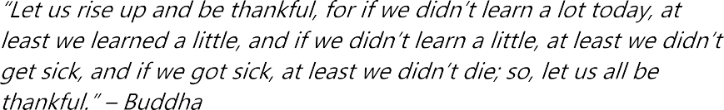

“Joy is the simplest form of gratitude.” – Karl Barth
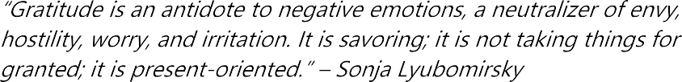

“What separates privilege from entitlement is gratitude.” – Brene Brown

Activity: Give each person four pieces of two short and two long strips of yellow/orange paper. In the middle of the table there is a sun/circle which has written on it: ‘I am grateful for...’ Explain what is going to happen.

In order to create an atmosphere of prayer, play some meditative music, and after a time of listening invite everyone to write on one of the longer pieces, one thing for which they are grateful and place it around the sun. If you wish, when everyone has contributed, bring down the music slightly and read out slowly the offerings. Do this three more times to build up the sun-filled picture. To close the prayer time invite all to join in with: ‘Glory be to the Father, and to the Son, and to the Holy Spirit; As it was in the beginning is now and ever shall be, world without end. Amen’.

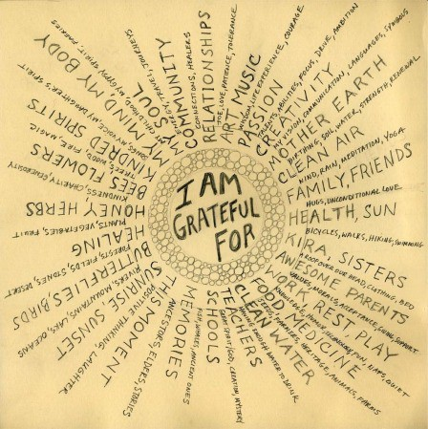
    - Give thanks with a grateful heart: Hymns Old and New 202
    - Now thank we all our God: Hymns Old and New 474
    - 10,000 Reasons (Bless the Lord) by Matt Redman

Activity for the Week
    - Go for a prayer walk and stop at certain places and simply give thanks out loud for what you notice.
    - Write a gratitude prayer or psalm to God.
    - Make a gratitude wall that the rest of the congregation could add to each week?

Prayer:
The soul of every living creature shall praise you, O Lord. Even if our mouths were filled with songs like the sea, our tongues with joy like the mighty waves, our praise like the breadth of the sky, we should still be unable to thank you enough for one thousandth part of the love you have shown us.

For you have redeemed us, freed, us, fed us, delivered us, saved us and spared
Reflecting for Lent
What is Jesus grateful for when he looks at the world today … at the church today … at your life today?

Joy

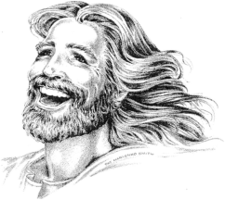
Introduction
There are many expressions of joy. But at its heart, it could be argued that joy can be experienced only when we feel safe. The meaning of being truly at home. Throughout Scripture we come across the peaceful, calm joy of resting in God, where we feel we can be truly ourselves.
In today’s study we’re going to concentrate on a
different type of joy through the life of Jesus. This type of joy is the exuberant, overflowing joy, a joy that is most often found and experienced in community. Like other forms and expressions of joy, this is only possible when we feel we can be truly ourselves with those we are with, when we feel ‘at home’ in the truest sense of the word.
It is most often expressed in laughter. Not the laughter at the expense of others – a ‘joy’ that we enter when we are insecure and are joyful at the expense of another, but the joy of abandon, of liberation, of hope.
Human beings find certain things joyful, babies laugh from an early age, we make humorous comments. A good laugh can restore our sense of humanity and we all know how powerful a smile or laugh can be in making other people relax. Laughter and smiling is infectious.
Since we are made in the image of God, it is logical to conclude that these gifts of joy and laughter come from God. Indeed, in Proverbs 8 we hear of the joy of wisdom at the moment of creation and Job 38-41 speaks of God’s playfulness at creation.
Jesus came that we may have life in all its fullness, and for humans, that fullness is often expressed in joy. This week we invite you to concentrate on this unfettered joy. A joy that bubbles up from within, that escapes when we remove our masks and feel completely at ease with those we’re with.

Gathering Questions
  - When was the last time you were truly joyful?
  - What makes you joyful?
  - Is joy always a response to something outside of yourself? What?
  - What is the difference between happiness, contentment and joy?
  - Have you ever felt guilty for being joyful? What is the relationship
between joy and grief? 9

Reflecting on Scripture
Shout with joy to the Lord, all the earth! Worship the Lord with gladness.
Come before him, singing with joy.
Acknowledge that the Lord is God!
He made us, and we are his.
We are his people, the sheep of his pasture.
Enter his gates with thanksgiving; go into his courts with praise.
Give thanks to him and praise his name.
For the Lord is good.
His unfailing love continues forever,
and his faithfulness continues to each generation. (NLT)

Many times in the Psalms, we are ‘commanded’ to be joyful, to sing rejoicingly. This Psalm is one such example:
  - How do you respond to these imperatives to joy?
  - Why do you think the Psalmist thinks is so important to be joyful? Do you agree?
  - Do things need to be going well for you to be joyful?
  - Can you be joyful in the midst of pain and suffering?

Other Old Testament readings which may help: Zephaniah 3:17, Proverbs 8:1- 4, 22-31 (the joy of Wisdom at the moment of creation)

Jesus …
Humour often does not carry across cultures – many of us know this from our own experiences of travelling to friends around the world. Our problem when approaching the gospel stories is that we are travelling through different cultures of time, space and language. Often the humour that he uses in his stories, is lost in translation.
The gospel narratives don’t speak of Jesus laughing and being full of joy. However, he was fully human and he spent a lot of time with his friends. Often reading the Bible imaginatively and placing ourselves in the story, gives us glimpses of when Jesus may have ‘mucked around with friends’, laughed at jokes, been truly joyful.

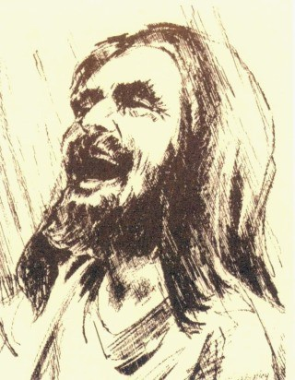
  - How do you respond to this picture?
  - How do you feel about the idea of Jesus being joyful? Laughing with abandon?

Jesus was clearly criticised for being joyful, for celebrating with his friends, and for enjoying the good fruits of food and drink. He also said that we should laugh and be joyful with him as we live in the presence of God.
  - Can you think of times when people have criticised you for ‘having a good time’, for ‘being flippant’ and enjoying yourself because they thought you should be more serious?

Luke 7:31-35
Jesus said: ‘To what then will I compare the people of this generation, and what are they like? They are like children sitting in the market-place and calling to one another,
“We played the flute for you, and you did not dance; we wailed, and you did not weep.”
For John the Baptist has come eating no bread and drinking no wine, and you say, “He has a demon”; the Son of Man has come eating and drinking, and you say, “Look, a glutton and a drunkard, a friend of tax-collectors and sinners!” Nevertheless, wisdom is vindicated by all her children.’

Matthew 9:14-15
The disciples of John came to him, saying, ‘Why do we and the Pharisees fast often, but your disciples do not fast?’ And Jesus said to them, ‘The wedding- guests cannot mourn as long as the bridegroom is with them, can they? The days will come when the bridegroom is taken away from them, and then they will fast.
How do you feel about Jesus being ‘a party animal?
Are there ways in which religion, your church, faith can take on a seriousness that is difficult to equate with joy? Why? When have you felt a joy in faith?

John 2:1-12 – the Wedding at Cana
In , we see Jesus at the wedding feast, sharing times with those he loved, dancing, joking with his disciples. If you want to watch it there is a 3min 23 sec clip here: https://www.youtube.com/watch? v=_xpuOMgX2Hg

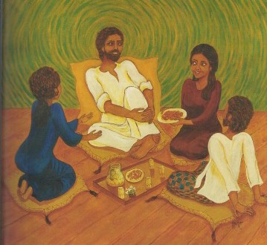
- How do you react to this scene?
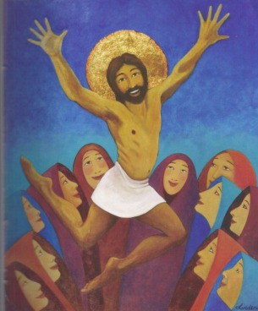
- What does it do to your faith journey to think of Jesus being joyful?

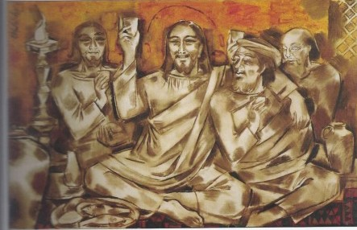
Other pictures
–
Lindena Robb
– Hanna Cheriyan Varghese
– Alphonso Doss
  - How do these pictures make you feel?
  - In what ways do they help you to encounter a new side of Jesus?
  - What difference does it make to your faith? Your life?

Parables – Jesus told many parables about God’s rejoicing when we return to God.
Read some of Luke 15 (Lost Sheep, Lost coin, Lost Brothers)
  - What would God’s rejoicing look like?
  - How does it feel that God rejoices in you, not just that God is ‘happy’ with you?
  - How does this reflection on ‘joy’ alter how you read these parables?
  - What does God’s joy look like for you?
  - How do you feel about being a ‘cause’ of God’s joy?

Jesus also used humour to teach, heal, convert and redeem. For Jesus, laughter and deep meaning are not mutually exclusive. Like any good speaker and teacher, Jesus knew that humour disarms and unites people, setting people at ease and ready to receive a message.
  - Can you think of occasions when Jesus used irony and wit to get his message across?

Some examples to help:
Matthew 15:14: The blind leading the blind
Matthew 23:24: Straining out a gnat while eating a camel. Obviously without Aramaic, many of the word plays are lost on us, here for example, the Aramaic word for gnat is galma and camel is gamla
Luke 11:11-12 – would a father give a snake if his child asked for fish? Mark 10:25 – can a camel pass through the eye of a needle?
Luke 6:41-42 – surely the idea of a person with a log in his eye trying to find something small in the eye of another would be ludicrous and silly!
Mark 4:21 – what fool would place a lamp under a bushel basket

  - How do we meet Jesus with joy and laughter in our hearts?
  - When have you heard an important message told with humour … what about messages of faith?
  - How do we make sure we don’t take ourselves too seriously especially when we’re speaking of faith?

Jesus’ Joy
In Luke 10:21 Jesus prays “rejoicing in the Holy Spirit”
  - What would it look like for us to pray by rejoicing?
  - Have you ever laughed in prayer?
  - How does our worship reflect or create joy for you?

Activity
The Psalms were the prayers of Jesus – they ‘command’ us to be joyful, and the stories they tell enabled a nation to be joyful and to see God’s abundant work around them. Some of those Psalms contain the whole range of emotions. But the Book of Psalms finishes with Psalm 150 – a full throated over abundant hymn of praise with everything we have. Sometimes this might feel very culturally alien to us … so tonight as a group write your own psalm of joy: (played like ‘consequences’)

On paper space out : (these are only examples)
  - I will praise the Lord for......
  - I rejoice in God because.....
  - Give thanks all you nations for....
  - I sing for joy because of...

Then fill in the first one and FOLD IT DOWN so the next person can’t see. Pass the paper to the right. The second person fills in the second sentence folds it
down and passes it to the right. After all sentences filled in unfold the paper and read out your psalms of Joy.

Prayer
Eternal Father, through your Spirit delighting in the world, you created us from joy and for joy:
grant us a deeper knowledge of the joy which is ours in Christ Jesus,
that here our hearts may be glad,
and in the world to come our joy may be full:
for with the Son and the Holy Spirit, you are our God, now and for ever.
(Raymond Hockley, 'The Order for Evening Prayer' - York Minster)

Living it out
- What do you think about the phrase “to live is to be joyful”?
- Can you cultivate joy? How?
Reflecting for Lent
Why is Jesus joyful today when he looks at the world … at the church … at your life?

Anger

Gathering Together
Make a list of words we use for anger. Arrange them in order from the least angry to the most.
Can you think of situations that might create each of these reactions?

Image: "The Angry Christ"
  - How do you respond to this image of Jesus?
  - How does it make you feel?
  - Does it fit with your usual picture of him?

The painting comes from the Philippines, during the time of the Marcos dictatorship. It was painted by Lino Pontebon, a young
artist, in response to the suffering of indigenous people at the hands of unscrupulous developers, the international sex-trade and the military. It captures the anger of people whose lives are manipulated by forces outside their control.
  - Does this background change the way you think or feel about the image? If so, how? If not, why not?
  - The painting has become popular around the world, especially with the young. Why do you think that might be?
  - Anger can be a one of the most difficult emotions for many Christians to deal with. Why do you think that is?

Exploring the Scriptures
Then Jesus entered Jerusalem and went into the temple, and when he had looked around at everything, as it was already late, he went out to Bethany with the twelve.

On the following day they came to Jerusalem. And he entered the temple
and began to drive out those who were selling and those who were buying in the temple, and he overturned the tables of the money changers and the seats of those who sold doves, and he would not allow anyone to carry anything through the temple. He was teaching and saying, “Is it not written,
‘My house shall be called a house of prayer for all the nations’?
But you have made it a den of robbers.”
And when the chief priests and the scribes heard it, they kept looking for a way to kill him, for they were afraid of him because the whole crowd was spell- bound by his teaching. And when evening came, Jesus and his disciples went out of the city.

Following the emotional high of riding into Jerusalem, Jesus went to the Temple, the central religious institution of his faith. Like some of the prophets before him, Jesus was enacting a parable of God's judgement on the Temple.
  - How would you describe Jesus' feelings in this passage: was he in a bad mood; did he get carried away in the moment; was it a planned set of actions? Does your answer make a difference to how you think of Jesus? If so how? If not, why not?
  - Do you think this was an appropriate response by Jesus? In what other ways might he have responded?
  - What might Jesus be angry with in our world today?
Again Jesus entered the synagogue, and a man was there who had a withered hand. They were watching him to see whether he would cure him on the Sabbath, so that they might accuse him. And he said to the man who had the withered hand, “Come forward.” Then he said to them, “Is it lawful to do good or to do harm on the Sabbath, to save life or to kill?” But they were silent. He looked around at them with anger; he was grieved at their hardness of heart and said to the man, “Stretch out your hand.” He stretched it out, and his hand was restored. The Pharisees went out and immediately conspired with the Herodians against him, how to destroy him.

Here Jesus is angry not at an institution but at people. We see this again Matthew 23 when he calls the scribes and Pharisees "hypocrites", "blind guides" and compares them to white-washed tombs that are full of "all kinds of filth". It's strong stuff!

  - What do you think stirred Jesus to anger in this story?
  - How do you feel about Jesus being angry with people around him rather than with an institution?
  - Here Jesus' anger only showed in his face. In Matthew 23 he put it into words by insulting them. In the Temple, he expressed it in both words and actions. What difference, if any, does it make how we express our anger?

Going Deeper in Discussion
  - Does it help you to know that Jesus got angry too? Or does it reinforce an unhelpful, even harmful, image of God as an angry God? Why?
  - Do you think it would be a good thing if more Christians got angry (or angrier) in response to what goes on around us? Why/why not?
  - What makes you angry? How do you feel about it afterwards?
Be angry but do not sin; do not let the sun go down on your anger, and do not make room for the devil.
  - Do you think it is possible to be angry and not sin? If so how? If not, why not?
  - What are the consequences of holding on to our anger - for us or for others?
  - What helpful strategies might enable us to "not let the sun go down on our anger"?

William Blake wrote that we needed to "seek the form of heaven with the energies of hell".
Blake knew that our deep feelings, our passions, can so easily be misdirected and become "hellish". However, he believed they are fundamentally good and God-given, and need to be harnessed, channelled in the right way, if we are to find the energy to seek and build God's kingdom in the world.
  - Do you think that anger can ever be a helpful emotion, useful in the service of God?
  - If so, how we can make sure it is constructive not destructive?
  - "Love and anger always opposed." "Anger and love can be two sides of the same coin." Which statement do you agree with more and why?

We sometimes describe Jesus' anger in the two gospel stories as "righteous". There is a lot of this sort of anger in the Bible - especially as the prophets speak of God's reaction to the idolatry, injustice and violence around them. However, as St Francis de Sales pointed out (in an age before inclusive language): "there was never an angry man that thought his anger unjust."
  - Do you think it is helpful to think of some anger as "righteous"? Or is it unhelpful, or even dangerous? Why do you think that?
  - What is the difference between "righteous anger" and other sorts of anger? [Is it what causes it? Or how it is expressed? Or what impact it has? Or ]
  - What difference might it make if we could align our anger with God's anger? What could we do to help that to happen?

Both gospel stories end with Jesus' opponents responding with anger of their own and plotting violence against him. In the world today we see a great deal of anger that fuels other anger.
  - How do you react to the anger of others?
  - Is it possible to challenge what is wrong in the world without creating more anger in return?
Why do you think there is so much anger in our world today? How do you think Christians should respond to this?

Activity
- In the light of the discussion, you could invite members to express the colours of anger using paints or crayons.
- Make a collage from newspapers on the theme of anger (yours or other people's).

Prayers
Jesus Christ is raging, raging in the streets, where injustice spirals and real hope retreats. Listen, Lord Jesus,
I am angry too:
in the kingdom's causes
let me rage with you. (John Bell and Graham Maule)

O my Lord, I discern in my anger a sense of self-righteousness which is too close to pleasure. And I think of you, Lord. You were never angry in your own defence, and you took no pleasure in anger: else why the Cross? But you were angry for God: you were angry with those who sold him as a commodity; you were angry with those who used him for their own status; or who treated him as belonging only to them.

O Lord, implant in me a holy fear of the wrong kind of anger, which ministers to my own sense of self-importance, or is simply an indulgence of my own frustration. Forgive me, Lord, for all such occasions.
(Ruth Etchells)

This Week
Write a letter of protest about something you care deeply about. Put it aside for a few days and then look at it again.
Do you want to send it to someone?

Reflecting for Lent
Why is Jesus angry today when he looks at the world … at the church … at your life?

Compassion

The word Compassion literally means ‘to suffer together’. It is the emotion that arises when we can see the suffering of another and are motivated to do something about it. Empathy is similar, being the ability to place ourselves in the shoes of another and understand the perspective of another. But compassion, which can arise from empathy, goes further by
and actively reduce the suffering of another often at a cost or risk to the helper. These actions are seen as kindnesses.
Research has shown that compassion and kindness are deeply rooted in human nature – and that our first impulse is to help rather than compete. Even the very young can show innate compassion.
It has also been shown that practising compassion has benefits: it increases happiness, brings satisfaction, boosts health and longevity and encourages self confidence and resilience. Compassion also increases social connection and acceptance and contributes to the building up of quality relationships.

“Compassion is the radicalism of our time.” ~ Dalai Lama
If you want others to be happy, practice compassion. If you want to be happy, practice compassion.” ~ Dalai Lama

- What is the difference between pity, empathy, compassion?
- How do you respond to the two comments made by the Dalai Lama?
- Why do you think that practising compassion has such benefits?
- Share one time you’ve felt compassionate.
- What does it feel like to be compassionate?

Psalm 145:8-9
The Lord is gracious and compassionate, slow to anger and rich in love.
The Lord is good to all;
he has compassion on all he has made.

- How do you relate to this image of God?
- What does God’s compassion look like?
- How does God ‘have compassion on all he has made?’

As compassion is a part of God’s nature, we shouldn’t be surprised to read of Jesus’ compassion for the people he met.

Mark 1: 40 – 42: A leper came to beseeching Jesus and kneeling said to him, “If you will, you can make me clean.” Moved with compassion Jesus stretched out his hand and touched him, and said to him, “I will. Be clean.” And immediately the leprosy left him and he was made clean.

Matthew 9: 36 When Jesus saw the crowds, he had compassion for them, because they were harassed and helpless, like sheep without a shepherd.

Luke 7: 11 – 15 Soon afterward Jesus went to a city called Nain, and his disciples and a great crowd went with him. As he drew near to the gate of the city, behold, a man who had died was being carried out, the only son of his mother, and she was a widow; and a large crowd from the city was with her. And when the Lord saw her, he had compassion on her and said to her, “Do not weep.” And he came and touched the bier, and the bearers stood still. And he said, “Young man, I say to you, arise.” And the dead man sat up, and began to speak. And he gave him to his mother.

Matthew 23:37 “Jerusalem, Jerusalem, who kills the prophets and stones those who are sent to her! How often I wanted to gather your children together, the way a hen gathers her chicks under her wings, and you were unwilling.”

- Consider these times when Jesus was compassionate. With each one discuss what was he feeling and why? And what was his response?
- How does reading these passages make you feel about Jesus?
- How might these stories change your relationship and prayer life with
Jesus? 21

“Homeless Jesus”
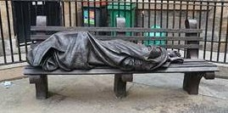

This bronze sculpture, by Canadian artist Timothy Schmalz, was first installed in Toronto in 2013. Since that time over 100 casts have been commissioned worldwide and they now sit on the streets of such cities as Paris, Manchester, The Vatican and Glasgow (see above, in Nelson Mandela Place). The face and hands of the rough sleeper are obscured but the crucifixion wounds on his feet reveal his identity. A space has been a deliberately left at the end of the bench for anyone to come and sit down next to Jesus. Reactions to this sculpture have been vastly mixed, with some thinking it demeans the personhood of Jesus.

- What is your reaction to this sculpture?
- If you sat at the end of the bench, what would you like to say to Jesus?
- What action might you wish to take after seeing this sculpture?

Read this prayer together or silently by yourselves...
Prayer of St Teresa of Avila
Christ has no body but yours, no hands, no feet on earth but yours.
Yours are the eyes with which he looks compassionately on this world.
Yours are the feet with which he walks to do good.
Yours are the hands, with which he blesses all the world.
Yours are the hands. Yours are the feet.
Yours are the eyes. You are his body.
Christ has no body now but yours, no hands, no feet on earth but yours.
Yours are the eyes with which he looks compassionately on this world.
Christ has no body now on earth but yours. Amen.
or listen to a recording of it sung with music by David Ogden...
or by John Michael Talbot

- As Jesus looks at the world today where might his compassion be particularly directed?
- Where are people already demonstrating the compassion of Jesus in the world by being his hands, feet, body?
- To whom might it be difficult to feel compassion for?
- How might we respond to our compassion? How might we include others in our actions?
- Why might it be difficult to believe that Jesus looks on you with compassion when life is tough?
- How do you respond to the compassion of Christ in your life?

Activity: Give everyone 4/5 strips of paper to write down either places/situations we need to pray for with compassion; or actions we might do in response to this compassion. Once completed glue these strips into a paper chain and display.
Holding these places that need our compassion in mind consider the following quotations: Which quote speaks particularly to you?

“If we have no peace, it is because we have forgotten that we belong to each other.”
Mother Teresa
“Compassion is the basis of morality.”
Arthur Schopenhauer

Prayer
“Compassion hurts. When you feel connect- ed to everything, you also feel responsible for everything. And you cannot turn away. Your destiny is bound with the destinies of others. You must either learn to carry the Universe or be crushed by it. You must grow strong enough to love the world, yet empty enough to sit down at the same table with its worst horrors.”
Silent meditation: Imagine you are with Jesus as He looks at the world. Have a conversation with him, telling him what you feel, see and desire. Then listen to his reply.
Lord of the Universe,
look in love upon your people.
Pour the healing oil of your compassion on a world that is wounded and dying. Send us out in search of the lost,
to comfort the afflicted, to bind up the broken, and to free those trapped
under the rubble of their fallen dreams.
(Sheila Cassidy)

Activity for the week
Write a 4 x 4 Compassion Bingo card and see how many compassionate actions you can do this week (perhaps leave a couple of squares blank to respond to circumstances.) eg Make a cuppa for someone unasked, talk to someone new
Reflecting for Lent
Why is Jesus compassionate today when he looks at the world … at the church … at your life?

Weariness

Gathering Together
Image: “Tired Out” by Mahonri Mackintosh Young.
- How do you respond to this image?
- Make a list of words or phrases that it brings to mind. In what ways do they speak about different depths of weariness?
- Who might be feeling like this in our community, our society, our world today? Why?

Tiredness is of course a perfectly natural and good thing, reminding us that we need to rest. And we soon bounce back. However, when it goes very deep – whether physically, mentally or spiritually – we sense that we are “burnt out”, “running on empty”. Feelings
usually involve some kind of emotional energy, which we can channel in either helpful or harmful ways. However, profound weariness is different – it is a lack of energy that affects not merely our body but our mind and our spirit. Even so, symptoms of exhaustion can still be seen in our reactions to things – we may be more likely to respond with impatience or frustration, negativity or despondency. Doctors sometimes diagnose “exhaustive depression”. Some things drain us; others restore and refresh us.

Exploring the Scriptures
This is a summary of a day in the life of Jesus. (There is a similar account in Mark 6 v30-34)
  - What strikes you about this account?
  - What might have been draining for Jesus? What might have been restoring?
  - Who, today, might experience days as relentless as this?

Mark gives us a picture of Jesus sleeping – an essential human activity. John shows us Jesus tired, hot and thirsty.
  - His disciples thought that Jesus being asleep meant that he didn’t care. Why do you think he might have been able to rest during a storm?
  - Most of us have nights when sleep eludes us. When these come, are there any things you do that you find helpful?
  - Jesus was not afraid to ask for what he needed to be refreshed and re-energised. Do we sometimes find that hard to do? Why is that?
In bringing healing, Jesus was being drained of power, of energy. Because we are a psycho-somatic unity, using emotional and spiritual energy can be very draining physically as well. However, the things that drain one person might energise another.
  - How do you notice your energy changing through the day?
  - Make a list of what saps your energy or wears you down. If there are any that you feel comfortable sharing, feel free to do so.
  - Some of the things that drain us may be unavoidable, others we may be able to do something about. You may like to talk about some of these or to offer your list to God in prayer later.
Here Jesus seems to be weary of waiting for his followers and the people around him to grasp what he was about.
  - Can you think of other times when he reacts like this? Does this make Jesus easier to relate to, or do you think Jesus would always have been patient and positive? Why do you think this?
  - The Psalms have many cries of: “How long, O Lord!” (eg: Psalms 13 v1- 2; 74 v10; 89 v46; 90 v13; 94 v3) The writers were weary of waiting for a difficult time to end, or for God to act to save them. Who might be wearily crying out “How long!” in our world today and why?
  - If you were to cry out "How long, O Lord?", what sort of things would you be thinking of?

(see also Isaiah 40 v 28-31) Jesus knew what it was to be weary.

  - What “heavy burdens” do you think he carried during his life and ministry?
  - In what ways does your faith help to refresh and restore you?
  - How do we pray when we are really tired?
Mary, Martha and Lazarus seem to have been friends of Jesus; their home a place where he could go to be looked after.
  - How do they express their care for him in this story? Do you think it would have been hard for Jesus to let them minister to him? Why/why not?
  - Can you think of times when someone has helped restore you a little by their kindness or hospitality?
  - What renews and refreshes you – physically? mentally? spiritually?

Going deeper in discussion
- From your discussions, make a list of all the ways that Jesus tried to cope with tiredness, weariness, exhaustion, to “restore his soul.” (to quote psalm 23). Which of these do you find easy? Which do you find harder? Why?
- What might Jesus be weary or burdened with in our world today? Or does that idea not make sense to you? Why do you think this?

In Galatians, Paul writes: “Let us not grow weary in doing what is right, for we will reap at harvest-time, if we do not give up.” (6v9) Is there one thing from this session that might help you to do this?

Activity
Do something as a group that might refresh you.
- Curl up like the picture on p25, and then do some deep breathing and stretch yourself up as you do so, roll down your shoulders and expand your chest.
- Have a cuppa as a group and sit in silence holding your hot drink
- Think of something from today’s discussion that refreshes you

Prayers (You may like to pray one or more of these for yourself or for someone else you know.)

I heard the voice of Jesus say, “Come unto Me and rest;
Lay down, O weary one, lay down your head upon my breast.” I came to Jesus as I was, weary, worn, and sad;
I found in Him a resting place, and He has made me glad. (Horatius Bonar)

O love that will not let me go I rest my weary soul in thee
I give thee back the life I owe
That in thine ocean depths its flow
May richer, fuller be. (George Matheson)

Lord, I am poured out, I come to you for renewal. Lord, I am weary, I come to you for refreshment. Lord, I am worn, I come to you for restoration.
Lord, I am lost, I come to you for guidance. Lord, I am troubled,
I come to you for peace. Lord, I am lonely,
I come to you for love. Come, Lord,
Come revive me Come re-share me
Come mould me in our image.
Re-cast me in the furnace of your love. (David Adam)

This week
- Is there someone you are aware of who is carrying a heavy burden? Is there anything you could do to lighten their load just a little?
- Try to do one thing this week that helps to refresh and restore you.

Reflecting for Lent
Why is Jesus weary today when he looks at the world … at the church … at your life?

Holy Week

Many groups do not meet in Holy Week as the services of this week enable them to walk with Jesus through the events leading to his death. However, all the emotions that we have used in this short course (and many others) are present during the events of that week. This week we offer space for reflection
- concentrating on Jesus’ emotions and your emotions. There are many ways this could be done – perhaps on your own, or in a discussion group, or it could form the backbone to daily Morning Prayer during the week.
This is the week when Jesus is most fully human. A week when he could have used ‘divine powers’ to change the events in which he becomes embroiled. It is a week in which heightened human emotions lead to horrific consequences and a week when those very same human emotions are given new meaning as Jesus encounters and lives those emotions.
Jesus’ Holy Week is a roller coaster of emotions, and that is often our experience of emotions. We don’t feel ‘just one’ emotion at once, wallow in that and then move on to the next one. So often we have conflicting emotions
- the first time we find ourselves laughing after the loss of a loved one, the weariness that often leads to or accompanies our anger, our compassion for those with whom we still feel anger and so on.
This week Jesus fully enters the whole rainbow of human emotions – he takes all these emotions, our responses to the world, to other people, to ourselves, to the cross … not to rid us of emotion, but to demonstrate God’s love in all our humanity, in our anger and gratitude, in our weariness and joy. In this moment, Jesus feels all these emotions – and purifies them – in God, there are no ‘good’ or ‘bad’ emotions, it is how we respond to our emotional turmoil that can be either life giving or life destroying.
As you walk through Holy Week, can you encounter Jesus, be alongside him in his humanity, in his emotions and can you ask him to take your anger, hurt, your compassion and joy, your weariness, and gratitude, to turn them to the work of God’s kingdom.
This is a week when imaginative reading of Scripture forms the backbone of our daily services and rituals. As you live this week, name your own emotions as a response to the events. For this course on the Emotions of Jesus, we offer some pictures alongside a Scriptural reading for each day.
In each passage, Jesus responds to others and since he is fully human, he will have responded emotionally. Take each passage to explore how Jesus

expresses his emotions, what he does with his emotions, and how similar your emotions are. What is Jesus asking you to do with your emotions today?
- What are Jesus’ emotions in this story?
- What are the other characters feeling in the story?
- What are your emotions as you read the story?
- What are the occasions in the world, in the life of the church, in your own life, today that Jesus responds to with the same emotions?
- How does the story connect with your life?
- How might these reflections motivate you to respond?

Palm Sunday: Jesus encounters the crowd: Matthew 21:1-11
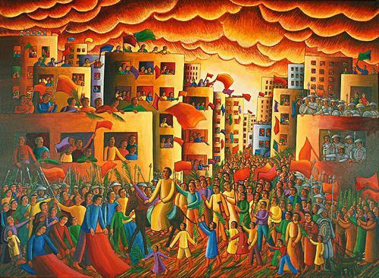
Jesus of the Palms,
as you enjoyed the crowd's welcome at the gates of Jerusalem, so may we rejoice at your gracious entry into our hearts
and never cease to sing your praise.

Monday: Jesus encounters Mary: John 12:1-8
Jesus of the Oils,
as you received the devotion and gratitude of Mary, so may we be poured out for you,
and hear again your gracious words to us.

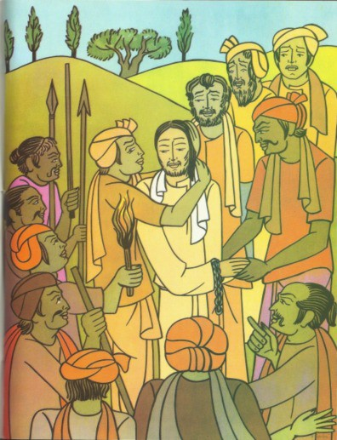
Tuesday: Jesus encounters Judas: Matthew 26:47-56

Jesus of the Darkness,
as you heart was broken for your friend Judas,
yet still received his kiss,
so may we share your tears for those who have lost their way.

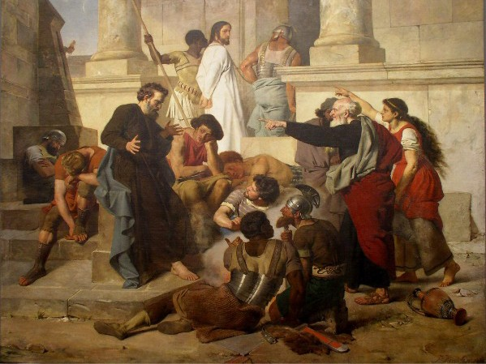
Wednesday: Jesus encounters Peter: Luke 22:54-63
Jesus of the Trials,
as you looked on Peter with understanding, and held firm in your own faith,
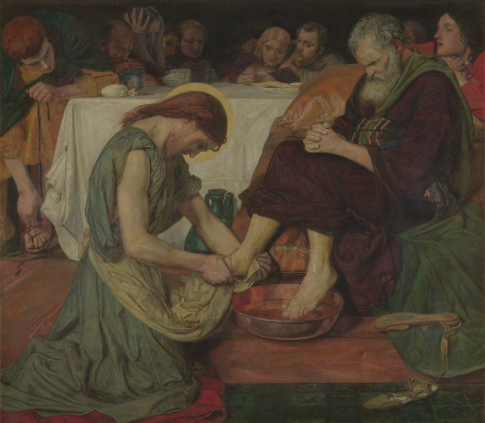
have compassion on us in our times of weakness and failure.

Thursday:
Jesus encounters the disciples:
John 13:1-17
Jesus of the Waters, as you washed the feet of your weary disciples,
so may we be refreshed by your touch
and then kneel at the feet of others.

Friday: Jesus encounters Pilate and the Sanhedrin: Matthew 26:57-68 and 27:11-26
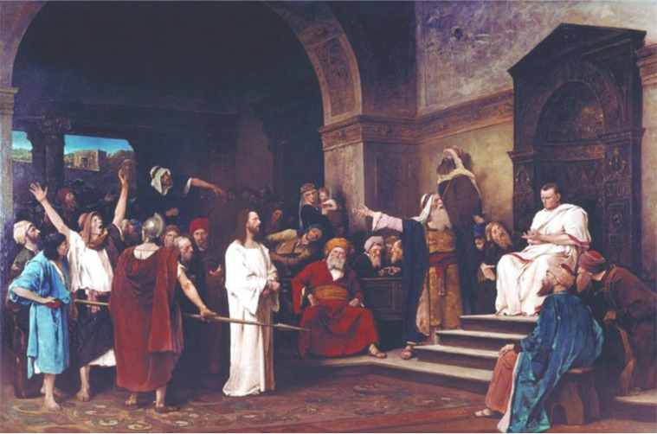

Jesus of the Cross,
as you bore a load beyond our imagining, and knew what it was to feel abandoned,
may all who bear a cross today know the assurance of your presence.

Permission and Source for Images:
Cover Christ Pantocrator Icon, Sinai, 6th Century, Public Domain
p9: ‘Laughing Jesus’, Pinterest https://www.pinterest.co.uk/pin/426082814764038522/ p11: ‘The Laughing Christ’ Christ the Liberator, Willis Wheatley, Contained in “The Christ We
Share” (©CMS, USPG, Methodist Church 1999), from “The Bible Through Asian Eyes”, edited: Masao Takenaka and Ron O'Grady, Published: Pace Publishing/Asian Christian Art Assoc.
p12: ‘The Chosen’, Angel Studios, Season 1 Episode 5. Used with permission. p12: ‘Behold the Joy of Jesus’, Lindena Robb, ©MIAT, Jesus Laughing Exhibition
https://www.miat.org.au/jesus-laughing-exhibtion.php
p12: ‘The First Supper’, Alphonso Doss, ©MIAT, Jesus Laughing Exhibition https://www.miat.org.au/jesus-laughing-exhibtion.php
p12: ‘Jesus at the Bethany Home’, Hanna Cheriyan Varghese, ©MIAT, Jesus Laughing Exhibition https://www.miat.org.au/jesus-laughing-exhibtion.php
p15: ‘The Angry Christ’, Lino Pontebon, Contained in “The Christ We Share” (©CMS, USPG, Methodist Church 1999), from “The Bible Through Asian Eyes”, edited: Masao Takenaka and Ron O'Grady, Published: Pace Publishing/Asian Christian Art Assoc.
p20: ‘Rabbits and Toddler’, Pinterest (original source unknown) https://www.pinterest.co.uk/pin/229965124701841989/
p22: "Homeless Jesus" Sculpture by Timothy Schmalz, Nelson Mandela Place, Glasgow, license https://creativecommons.org/licenses/by/2.0/deed.en
p25: ‘Tired Out’ – Mahonri Mackintosh Young. [Credit Frank Ruggles – Public Domain]
p30: Swanson, John August. Entry into the City, from Art in the Christian Tradition, a project of the Vanderbilt Divinity Library, Nashville,
TN. https://diglib.library.vanderbilt.edu/act-imagelink.pl?RC=56544 [retrieved December 11, 2023]. Original source: Estate of John August Swanson, https://www.johnaugustswanson.com/.
p31: ‘Magdalene Anointing Jesus’ feet’, Frank Wesley, http://www.frankwesleyart.com/main_page.htm
p31: ‘Jesus Encounters Judas’, Sister Claire SMMI of India https://globalworship.tumblr.com/post/140646751255/holy-week-art-from-india-sr- claire-set-2
p32: ‘Peter Denying Christ’, Peter Jansson, public domain https://www.janssenart.de/pjalt/restoration/status33.htm
p32: John Madox Brown, Jesus washing Peter's Feet, 1852-6, Tate (N01394), digital image © Tate released under Creative Commons CC-BY-NC-ND (3.0 Unported) Photo: Tate, CC- BY-NC-ND 3.0 (Unported), see https://www.tate.org.uk/art/artworks/brown-jesus- washing-peters-feet-n01394
p33: ‘Christ before Pilate’, Mihaly Munkacsy, Public domain Other photos by members of the Diocese of Edinburgh

Every reasonable effort has been made to trace copyright holders of material reproduced in these resources, but, if any have been inadvertently overlooked, we would be pleased to hear from them.

Scottish Episcopal Church Diocese of Edinburgh 21a Grosvenor Crescent Edinburgh
EH12 5EL

For further details, please contact: Joanna Morris, Tel: 0131 346 9085 Email: jmorris@dioceseofedinburgh.org

© Diocese of Edinburgh 2024
This guide is offered for study groups in congregations and for individuals.
It should not be reproduced without permission and should not be available for sale.

