Diocese Safeguarding Handbook

Section 4: Quick Guides and Posters
4.1 Our PVG Co-Ordinator Poster Template for Noticeboards
4.2 Childline and Age UK information
4.3 Safeguarding Checklist
4.4 Safer Recruitment Checklist
4.5 PVG ID Requirements
4.6 Induction Checklist
4.7 Codes of Good Practice

4.1 PVG Co-Ordinator Noticeboard Poster

OUR PVG CO-ORDINATOR

Please speak to the PVG Co-ordinator if you have a concern about how children or vulnerable adults are treated.
Add Name of Congregation here

Photograph of
PVG Co-ordinator
Our PVG Co-ordinator is: | Telephone:

You may also contact the Provincial Safeguarding Officer:
Tel: 0131 225 6357 / 07881868387 Email: safeguarding@scotland.anglican.org

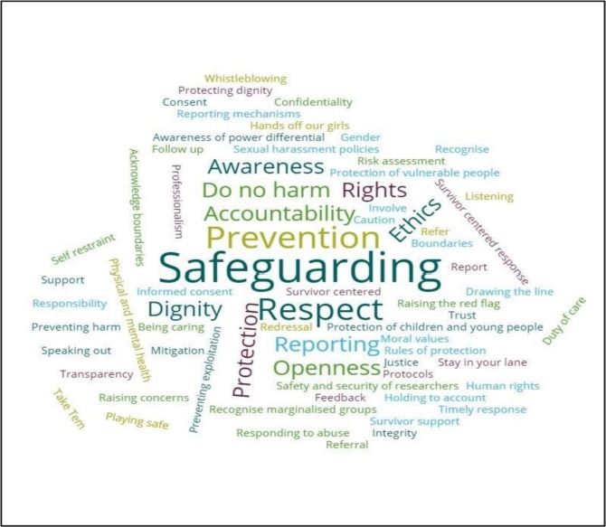
The witness of Scripture recognizes and affirms God’s love for all members of the human family and the priority given in Jesus’ ministry to children and the vulnerable of society. His ministry was one of welcome for all. To be free to worship and participate in the life of the Church, people need to feel safe and included. Good safeguarding practice helps to ensure that everyone is welcome in a church community. Good safeguarding practice is part of how we value people and treat them with respect.
We therefore commit ourselves to take all steps within our power to keep vulnerable people in our Church communities safe from harm and from abuse of trust.
4.2 Website Links
Sometimes, issues raised are not “safeguarding” and we may need to sign-post individuals to other organizations. The following organizations have lot of useful resources and information including posters for charges to use. The list is not exhaustive and can be customized to best suit your location.
It would be good practice to publicize the Childline and Silverline numbers on a noticeboard or in the charge magazine.
Childline
Now part of the NSPCC, Childline provides support for young people on line, by email or via the telephone (24/7)on a wide range of topics from exam results, bullying, addiction, abuse to mental health for children and young people. The site provides an easier to understand option for Under 12’s which is accessible from the main site and can be translated into different languages.

Click here to access the website: Childline www.childline.org.uk
Telephone 0800 11 11
Users on the O2 network may need to dial: 116 111 or use an on-line options.
O2 are working to rectify this problem.

AGE UK
Can offer advice and information to older people on a wide range of subjects including financial, legal, health and wellbeing, care, work and using the internet. It also offers a 24/7 be-friending service (silverline) for older people that may feel isolated:

The website can be accessed here: Age UK Or go to www.ageuk.org.uk
Telephone: 0800 077 8751
The Silver Line telephone number is: 0800 4 70 80 90

The Scottish Prison Service
The SPS has an excellent page on its website with lots of organisations that can offer support to families whether suffering the effects of imprisonment or not.

The website can be accessed here. Or go to www.sps.gov.uk/Families/WhereCanIGetSupport
Domestic Violence

4.3 Safeguarding Check-list

 |  | Notes
Is the SEC policy for safeguarding on display in the charge? | YES/NO
Are the Childline and Silverline numbers on display in the charge? | YES/NO
Does the charge have a PVG Co-ordinator? | YES/NO
Have they attended a PVG training course? | YES/NO
Are their name and contact details on display in the charge? | YES/NO
Is the PVG Co-ordinator involved in all recruitment within the charge? | YES/NO
Is the PVG Co-ordinator involved in the induction process for new workers and volunteers? | YES/NO
Does the Vestry have safeguarding on the agenda for meetings? | YES/NO
Is a safeguarding report presented at each AGM? | YES/NO
Do vestry members know who to contact regarding safeguarding if the PVG Co-ordinator is not available? | YES/NO
Has the vestry identified a “Regulated Work Employer”? | YES/NO
Does the vestry have a register of “Regulated Work” roles and Positions of Trust” within the charge? | YES/NO
Who is responsible for maintaining the register?
Is a record of safeguarding training maintained by the PVG Co-ordinator? | YES/NO

If the answer to any of these questions is no, action must be taken by the PVG Co-ordinator.

4.4 Safer Recruitment Checklist

This should be completed as part of the recruitment process for all roles both paid and un-paid and attached to the application form and paperwork of the successful candidate.

 |  | Notes
Has the PVG Co-ordinator been involved in the recruitment process? | YES/NO
Has the post paid or unpaid been advertised? | YES/NO
Has an interview panel been convened? (Required for both paid and unpaid roles) | YES/NO
Is everyone on the interview panel aware of the SEC Safer Recruitment procedures? | YES/NO
Have roles and questions been agreed by panel members? | YES/NO
Are job descriptions available for all posts paid and un-paid within the charge? | YES/NO
Have reference been taken up for all roles paid and unpaid? | YES/NO
Is the candidate aware that appointment is subject to references and a PVG Check (if required) | YES/NO
Has a PVG applications submitted and approved before the person commences? | YES/NO/NA
Does the staff member or volunteer have an identified supervisor to whom they report? | YES/NO if yes, please give name
Has the person been given safeguarding awareness training as part of the induction process? | YES/NO
Does the person know the name of the PVG Co-ordinator? | YES/NO

4.5 Checklist of ID Requirements for PVG Scheme Applications

Regardless of whether you are applying for PVG Scheme Membership or a Scheme Record Update you need to show your co-ordinator three proofs of ID of which at least one must be photographic, and the others must be recent official documents giving proof of current address.

Photographic Verification (at least one required)
1. Passport (UK or overseas)
2. Driving licence with photograph (also counts as one of the two required address verification documents)
3. Other forms of CURRENT photo ID: UK Government Department Pass/Card, Employee ID Card, NHS Scotland ID Card, Armed Forces ID Card, National Union Student ID, University ID, Young Scot Card

Verification of Current Address (at least two required)
1. Bank or building society statement (within last 3 months)
2. A utility bill (within last 3 months)
3. Credit or store card statement (within last 3months)
4. Financial statement (e.g. Mortgage, Personal loan papers, ISA)(within last 3 months)
5. Correspondence from statutory bodies (e.g. Benefits Agency, Employment Services; Central or Local/Government Departments) (within last 3 months)
7. Visa
8. Work Permit
9. Driving licence without photograph

Where the applicant cannot provide Photographic Evidence of Identity (Passport etc) If the applicant does not have the required documentation for photographic evidence then they should supply a passport sized photograph and a letter signed and dated by a responsible person which states ‘I certify that [name of person] residing at [full address] has been known by me for [duration of time]. Sign, address and date.’ Please note this letter should not be completed by the same person checking the identity.

4.6 Induction Check-list

New Employee / Volunteer
Induction Checklist
Name |  | Role
Church

The Church | Date | Questions
Facilities such as toilets, kitchen, break area, transport and parking
Provide a tour of the facilities, church and maybe the local area
Provide information about the other organisations who use the building
Expenses
Information about telephones, IT and keys if relevant
The Role
Introduction to the role
The role/job description including the boundaries of the role
Management and support information
Sign contract, confirmation of terms of appointment
Discuss any concerns about the role
Date of safeguarding training
Information on meetings and communications
Provide details about insurance
Provide any required equipment or uniform
Trial period and review date
Policies and Procedures
Provide information on policies and procedures within the Church and how to access them
The SEC/Diocese/Church website
Safeguarding Policies and Procedures
Health and Safety
First Aid
Code of Conduct
Confidentiality
GDPR

Signed by Worker |  | Date
Signed by Vestry Member |  | Date
Review Date

4.7 Code of Good Practice

  - Adopt the SEC Safeguarding Policy.

  - Always get references and follow Safer Recruitment procedures.

  - Ensure no-one commences a role until PVG checks have been completed (if applicable).

  - Ensure that all employees and volunteers have an agreed role description setting out clear responsibilities.

  - Ensure all employees and volunteers receive safeguarding training and know who to contact with any concerns.

  - Follow agreed procedures for protecting children and young people.

  - Discuss safeguarding procedures as part of the planning process for events.

  - Review proposals for out-reach work – is the church best placed to deliver the service or should it only sign post users to others?

  - Plan services and events to minimise situations where the harm or abuse of children/young people/vulnerable adults may occur e.g limit one-to-one contact, have parents/carers present as much as possible.

  - Consider pastoral visiting arrangements on an individual basis – do visits need two people?

  - Always get consent for children / young people to attend an event without parents.

